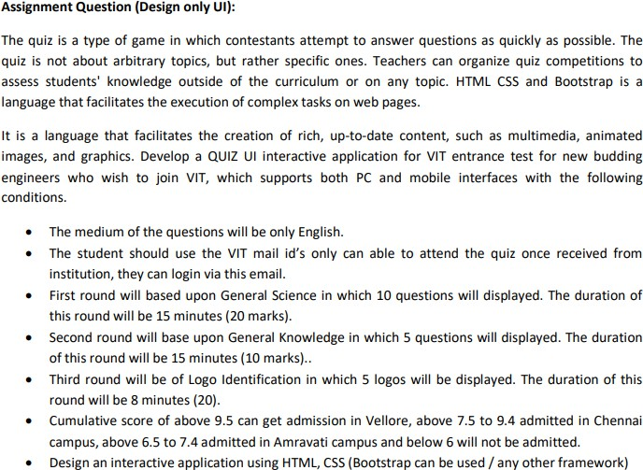

OUTPUTS:

* LOGIN PAGE:
* INVALID EMAIL ID

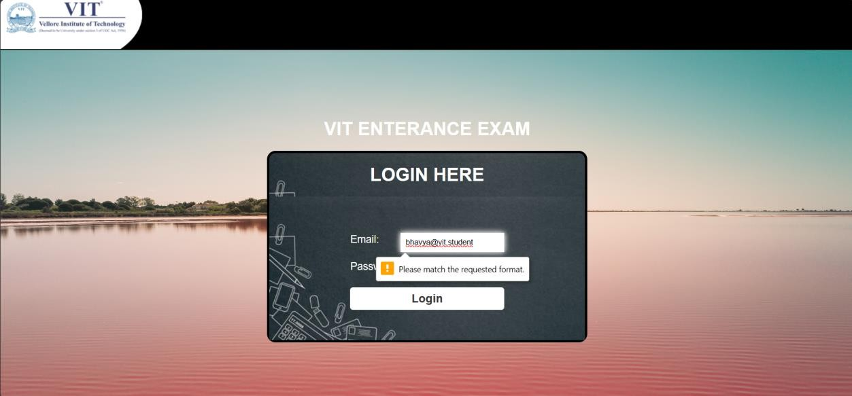

* INVALID PASSWORD

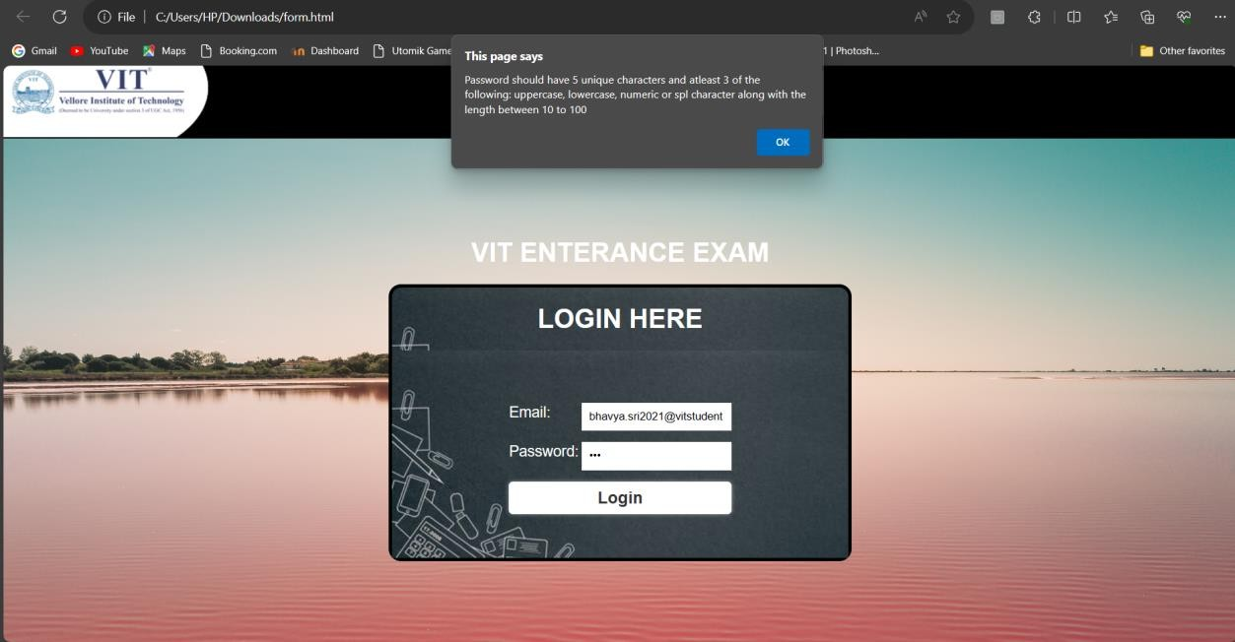

* After giving correct credentials

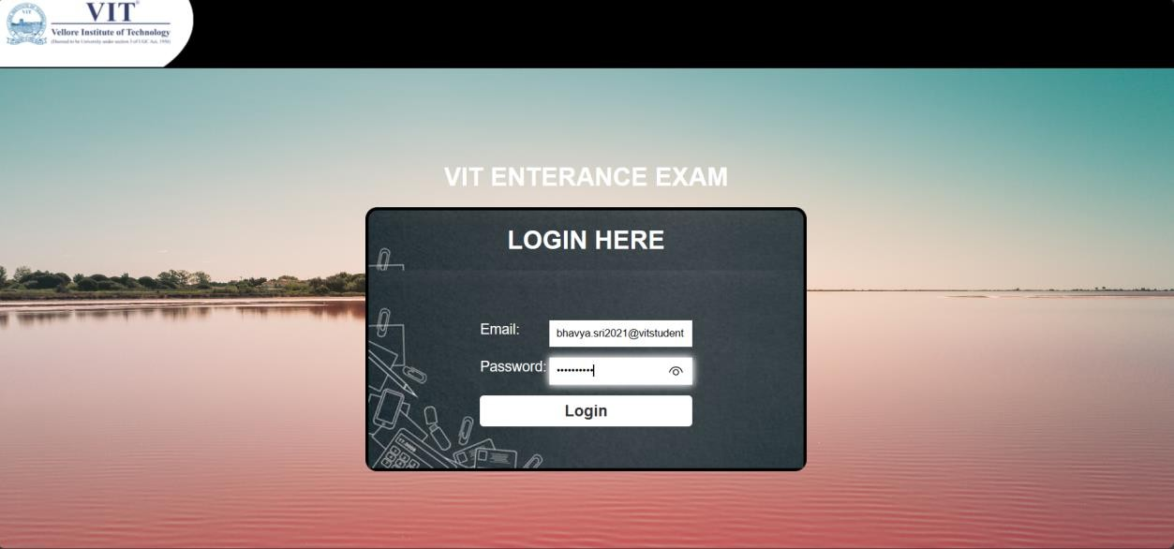

* Instruction page

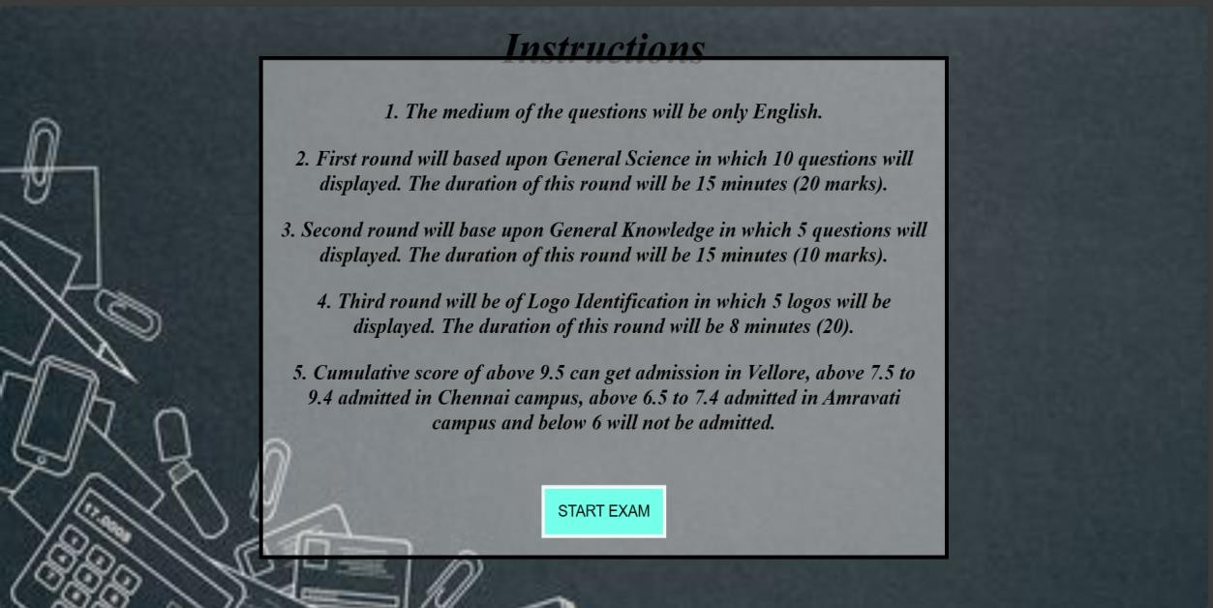

**Round 1**

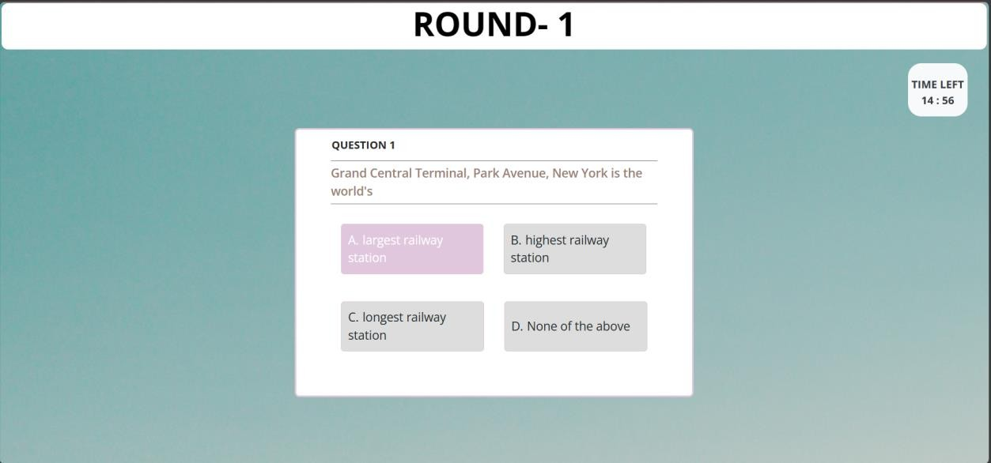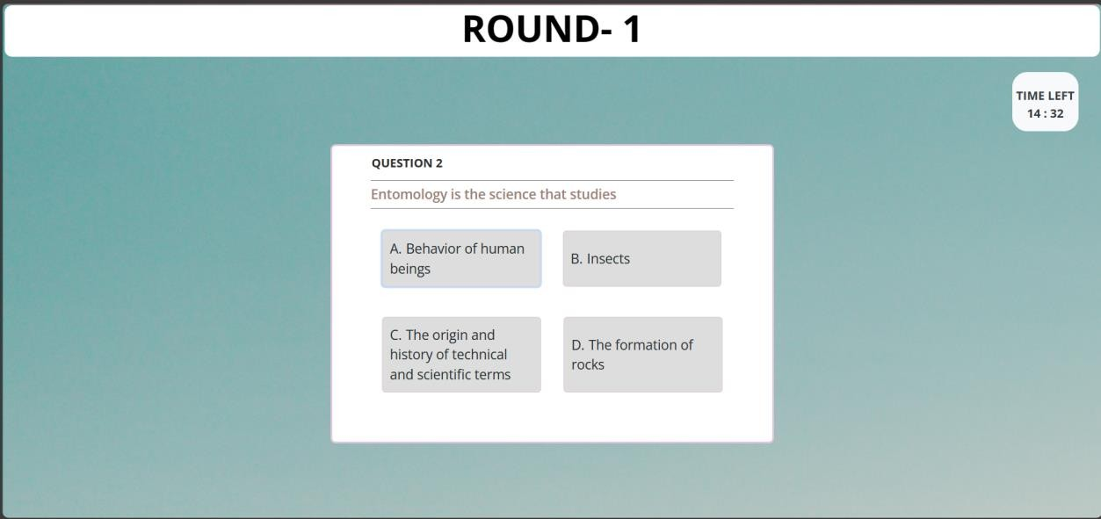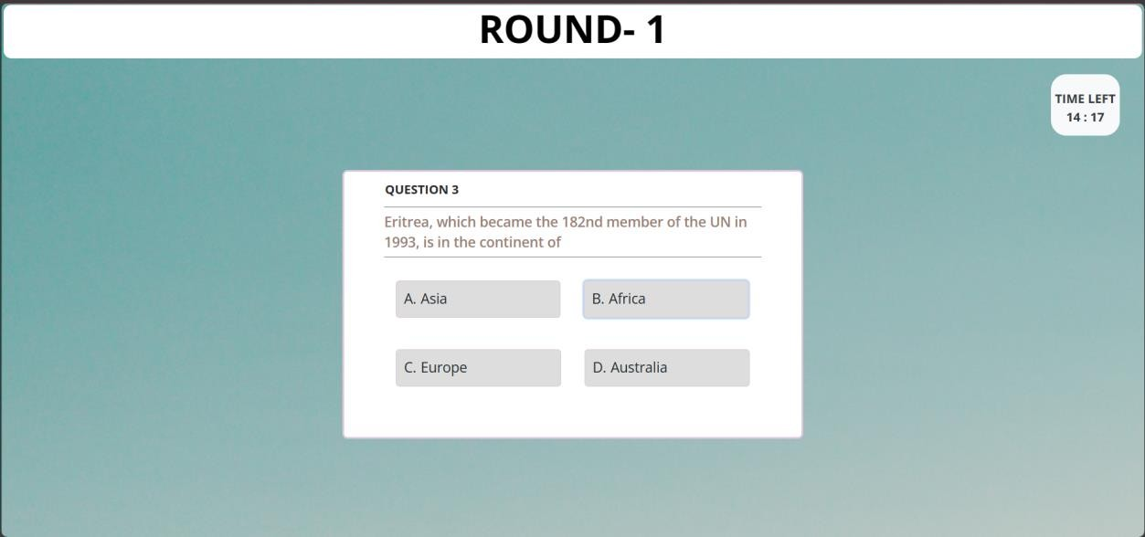

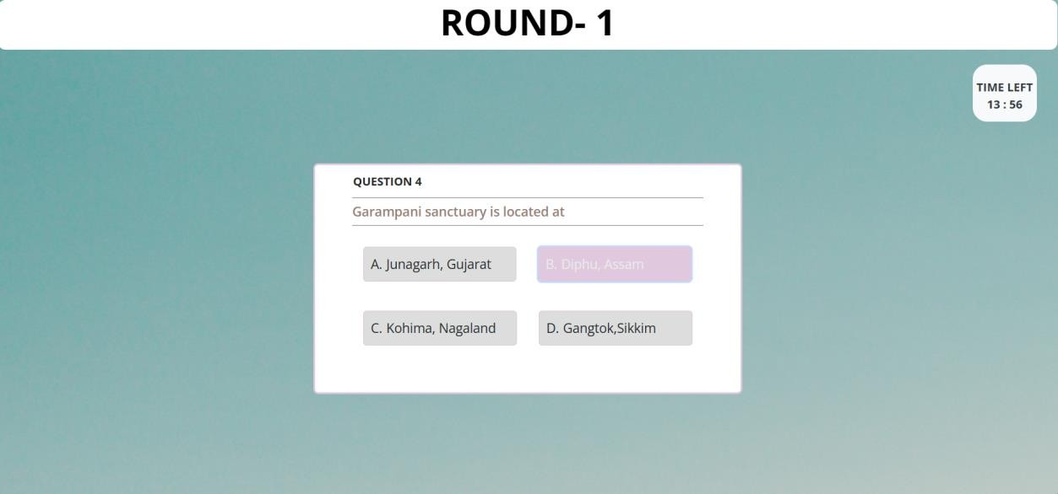

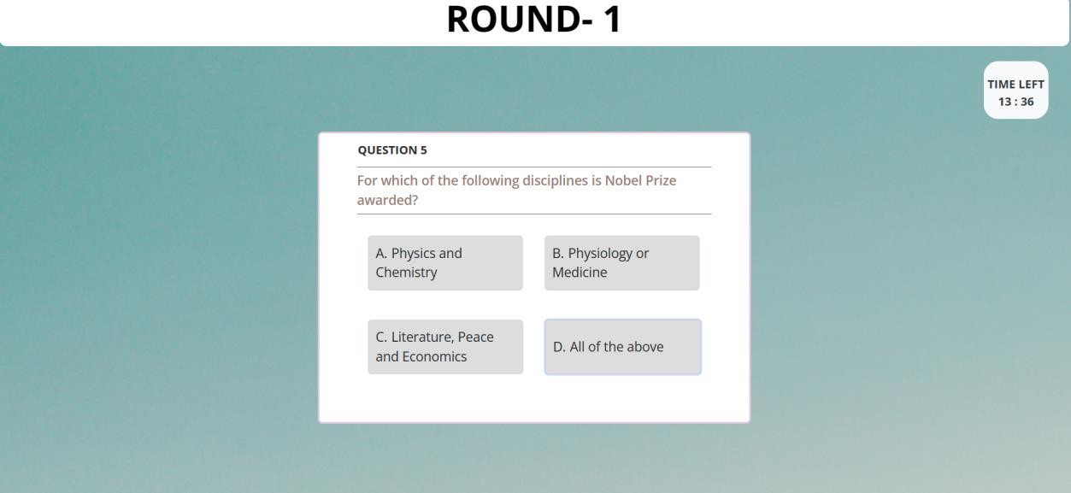

**Here I have given 10 question…..**

# Round -2

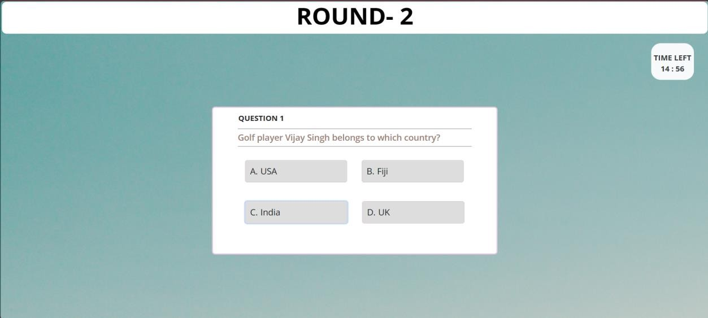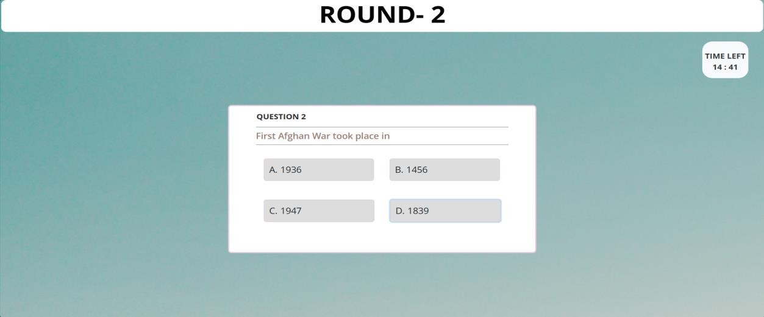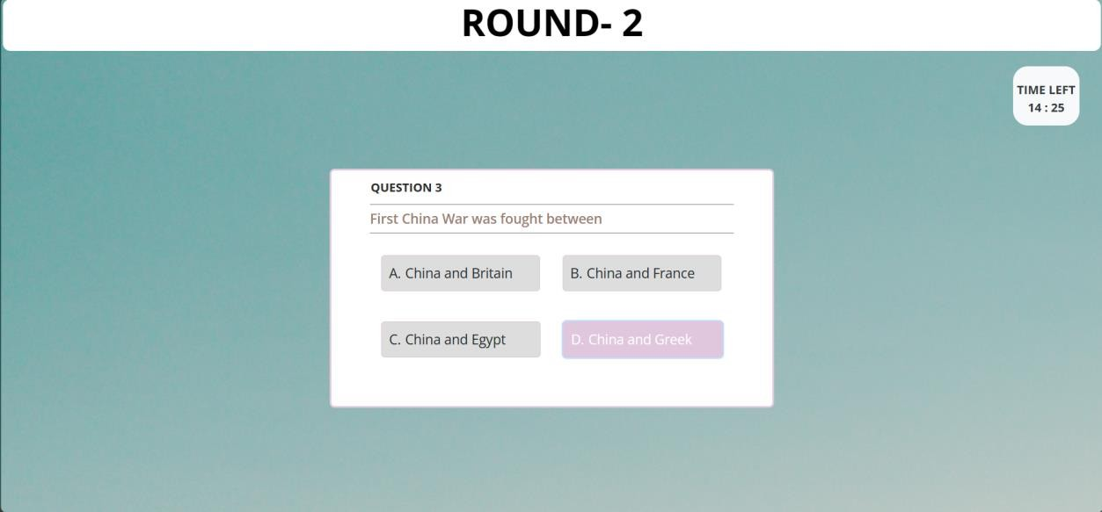

**Here we have some questions….**

**Round 3**

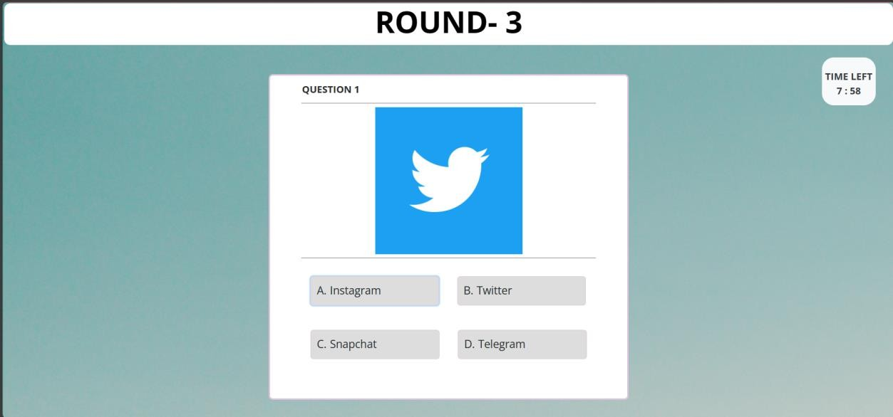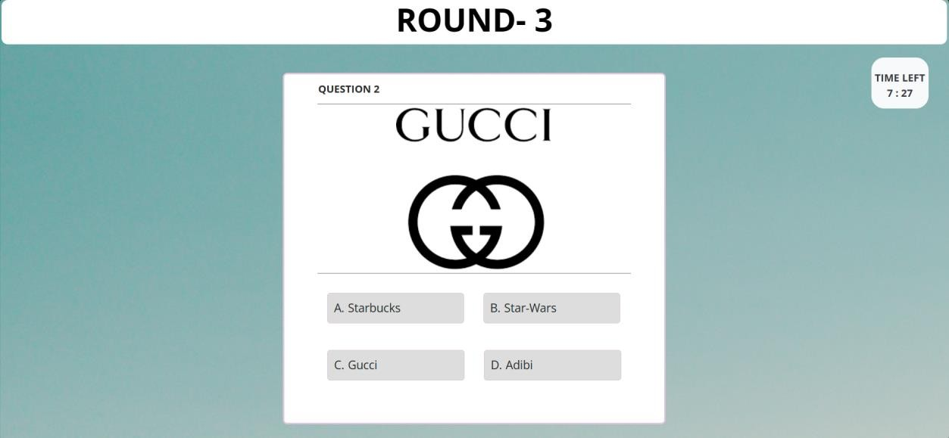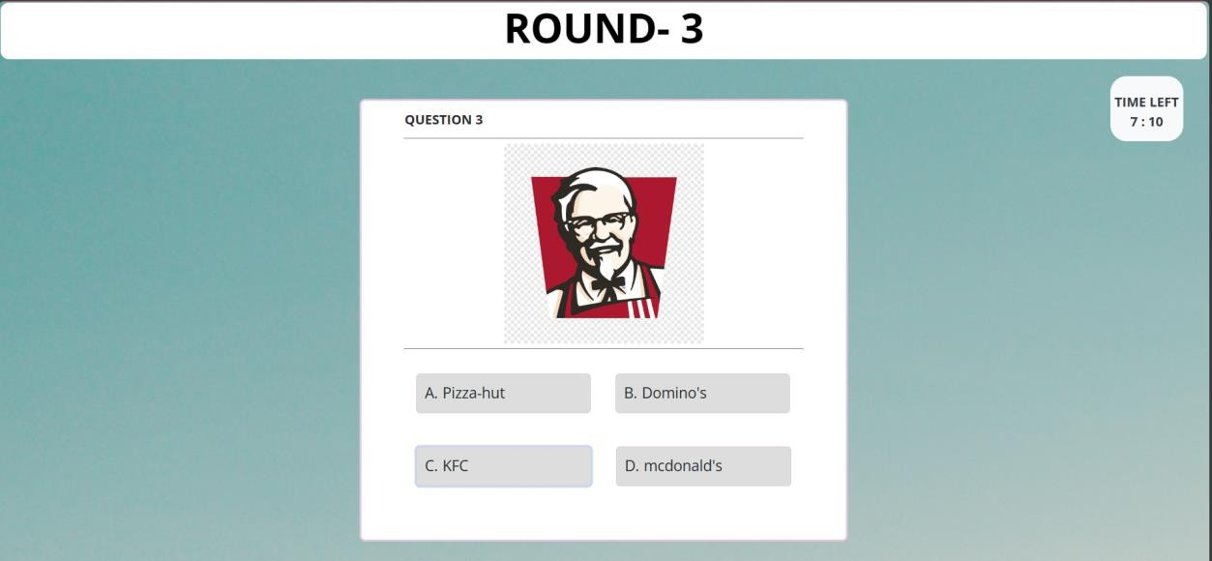

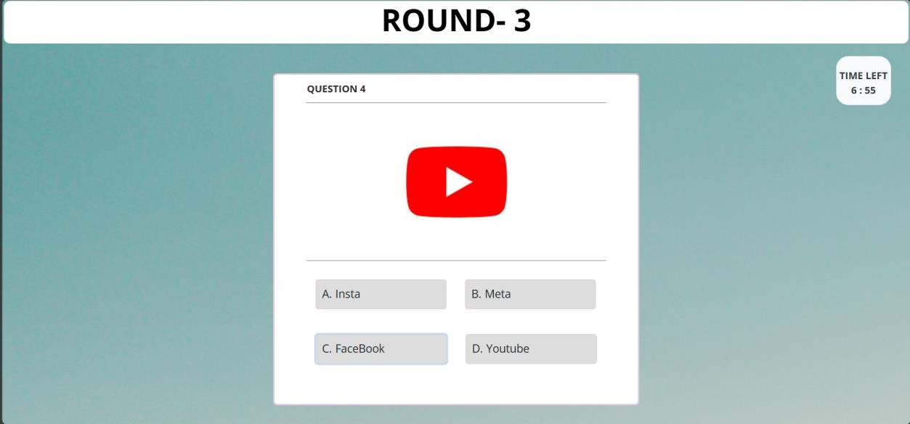

Result :

Cumulative score of above 9.5 can get admission in Vellore, above 7.5 to 9.4 admitted in Chennai campus, above 6.5 to 7.4 admitted in

Amravati campus and below 6 will not be admitted.

**Vellore campus:**

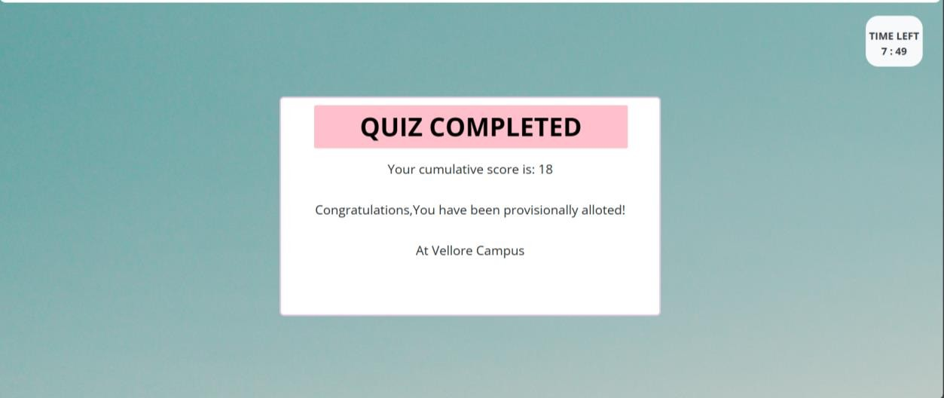

**Chennai campus:**

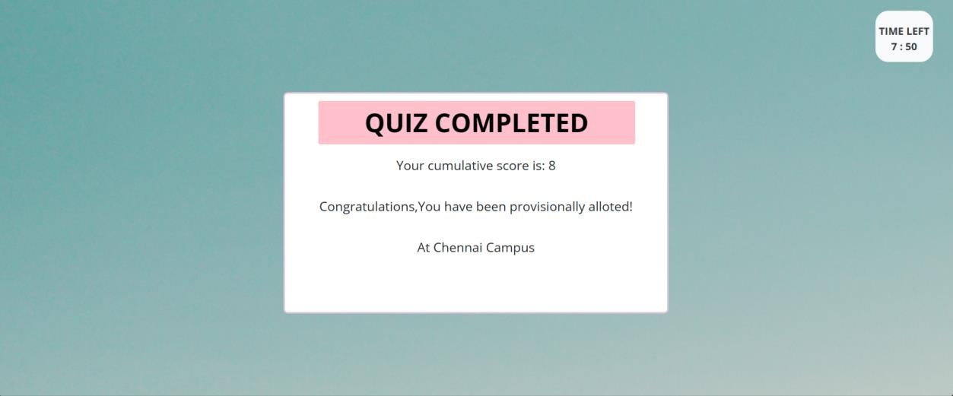

**Fail:**

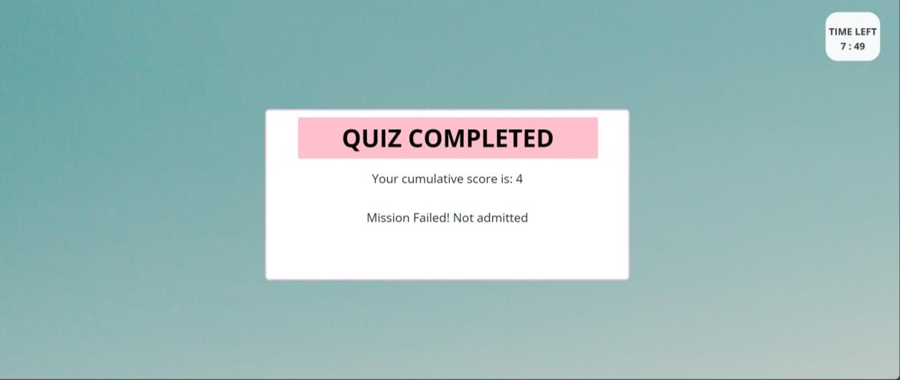

# Codes:

## HTML code:

<!DOCTYPE html>

<html lang="en">

<head>

<link rel="stylesheet"

href="https://stackpath.bootstrapcdn.com/bootstrap/4.5.2/css/bootstrap.min.css"

integrity="sha384-JcKb8q3iqJ61gNV9KGb8thSsNjpSL0n8PARn9HuZOnIxN0hoP+VmmDGMN5t9UJ0Z" crossorigin="anonymous">

<script src="https://code.jquery.com/jquery-3.5.1.slim.min.js" integrity="sha384- DfXdz2htPH0lsSSs5nCTpuj/zy4C+OGpamoFVy38MVBnE+IbbVYUew+OrCXaRkȠ"

crossorigin="anonymous"></script>

<script src="[https://cdn.jsdelivr.net/npm/popper.js@1.16.1/dist/umd/popper.min.js"](https://cdn.jsdelivr.net/npm/popper.js%401.16.1/dist/umd/popper.min.js)

integrity="sha384-9/reFTGAW83EW2RDu2S0VKaIzap3H66lZH81PoYlFhbGU+6BZp6G7niu735Sk7lN" crossorigin="anonymous"></script>

<script src="https://stackpath.bo otstrapcdn.com/bootstrap/4.5.2/js/bootstrap.min.js" integrity="sha384-B4gt1jrGC7Jh4AgTPSdUtOBvfO8shuf57BaghqFfPlYxofvL8/KUEfYiJOMMV+rV" crossorigin="anonymous"></script>

<meta charset="UTF-8">

<meta http-equiv="X-UA-Compatible" content="IE=edge">

<meta name="viewport" content="width=device-width, initial-scale=1.0">

<title>VIT ENTRANCE EXAM</title>

<link rel="icon" href="images/vit-img.ico">

<link rel="stylesheet" href="Quiz.css">

</head>

<body>

<div class="d-flex flex-row justify-content-center">

<h1 id="quiz-num" class="quizz">Quiz-x</h1>

</div>

<div class="d-flex flex-row justify-content-end mr-5 pt-4 ">

<p id="count-down" class="bg-light text-dark countt"></p>

</div>

<div class="container">

<div class="quiz-box">

<div id="quiz">

<div class="quiz-header">

<p id="progress">Question x</p>

</div>

<p id="question"></p>

<div class="buttons ">

<div class="d-flex flex-row pb-3">

<button class="btn m-4" id="btn0">

1. <span id="choice0"></span>

</button>

<button class="btn m-4" id="btn1">

1. <span id="choice1"></span>

</button>

<div>

</div>

</div>

<div class="d-flex flex-row">

<button class="btn m-4" id="btn2">

1. <span id="choice2"></span>

</button>

<button class="btn m-4" id="btn3">

1. <span id="choice3"></span>

</button>

</div>

</div>

</div>

</div>

</div>

</div>

<script src="Quiz.js"></script>

</body>

</html>

## CSS code:

@import

url('https://fonts.googleapis.com/css2?family=Open+Sans:wght@300;400;600;700&display=swap');

:root {

--white: #fff;

--black: #1c2b2d;

--blue: #31326f;

--light-blue: #005490;

--color-primary: #e0c7de;

--color-sec: #db6400;

--color-grey: #eee;

--color-dark-grey: #222831;

}

* {

margin: 1px; padding: 0;

}

html {

font-size: 10px;

}

body {

font-family: 'Open Sans', sans-serif;

background-image: url('C:/Users/HP/Downloads/beautiful-calm-pink-lake-blue-sky-captured- camarque-france.jpg');

}

p {

font-size: 1.6rem; line-height: 1.5;

}

img {

width: 100%;

}

.container {

max-width: 900px; margin-top: 0px;; padding: 0 20px; display: flex;

justify-content: center; align-items: center;

height: 60vh;

;

}

.quiz-box { width: 600px;

/* height: 500px; */

background-color: white; padding: 10px 50px 50px 50px;

border: 3px solid var(--color-primary); border-radius: 7px;

}

.quiz-box h1 {

background-color: var(--color-primary); font-size: 4rem;

text-align: center; color: #fff; padding: 10px 0;

width: 100%;

margin-bottom: 2rem; border-radius: 3px;

}

.quiz-header { display: flex;

justify-content: space-between; align-items: center;

}

.quiz-header #progress { color: #2b2b2b;

font-size: 1.6rem; font-weight: 700;

}

.quiz-header #count-down { font-size: 1.6rem;

font-weight: 700;

background-color: orangered; padding: 5px;

margin: 1px; color: #fff;

border-radius: 5px;

}

.quiz-box #question { font-size: 1.8rem; font-weight: 600;

color: rgb(154, 127, 118); border: 1px solid #777; border-width: 1px 0;

padding: 5px 0;

}

.buttons {

margin: 1.5rem 0 0 0;

}

.btn {

text-align: left;

background-color: #ddd; width: 100%;

font-size: 1.8rem; color: var(--black);

border: 1px solid var(--color-primary);

border-radius: 5px; margin: 7px 0; padding: 1rem; outline: none;

}

.btn:hover { cursor: pointer;

background-color: var(--color-primary); color: #fff;

}

.btn:active {

background-color: var(--color-sec);

}

.score {

color: var(--black); text-align: center; font-size: 2rem;

margin-bottom: 4rem;

}

.quiz-repeat {

text-align: center; margin: 0 auto;

}

.quiz-repeat a {

font-size: 1.6rem; font-weight: 600;

color: #fff;

text-decoration: none;

background-color: orangered; padding: 1rem;

border-radius: 5px; transition: all .3s;

}

.quiz-repeat a:hover {

background-color: var(--color-primary);

}

.quizz{

width: 1500px; border-radius: 10px; text-align: center; color: black;

height: 40px;

font-weight: bold; font-size: 50px;;

padding-bottom: 70px;; background-color: white;

}

.countt{

width: 400px;

text-align: center; height: 80px; width: 90px; padding-top: 20px;

border-radius: 20px; font-weight: bold;

}

## Javascript:

class Quiz {

constructor(questions, reward) { this.reward= reward;

this.score = 0;

this.questions = questions; this.questionIndex = 0;

}

getQuestionIndex() {

return this.questions[this.questionIndex];

}

guess(answer) {

if (this.getQuestionIndex().isCorrectAnswer(answer)) { this.score +=this.reward;

}

this.questionIndex++;

}

isEnded() {

return this.questionIndex === this.questions.length;

}

}

// Create a question Class class Question {

constructor(text, choices, answer) { this.text = text;

this.choices = choices;

this.answer = answer;

}

isCorrectAnswer(choice) { return this.answer === choice;

}

}

// NOW DISPLAY THE QUESTIONS

var fianlScore = 0;

function displayQuestion(count, quizElement, hasNext, next) { QuizNumber(count);

if (quizElement.isEnded()) { fianlScore += quizElement.score; if(hasNext){

clearInterval(quizTimer1); countDown2(15);

displayQuestion(2, quiz2, false, null);

}

else{

clearInterval(quizTimer2); countDown3(8); displayLogoQuestion();

}

} else {

// show question

let questionElement = document.getElementById("question"); questionElement.innerHTML = quizElement.getQuestionIndex().text;

// show options

let choices = quizElement.getQuestionIndex().choices;

for (let i = 0; i < choices.length; i++) {

let choiceElement = document.getElementById("choice" + i); choiceElement.innerHTML = choices[i];

guess("btn" + i, choices[i], count, quizElement, hasNext, next);

}

showProgress(quizElement);

}

};

function displayLogoQuestion(){ QuizNumber(3);

if (quiz3.isEnded()) { fianlScore += quiz3.score; showScores();

}else{

// show question

let questionElement = document.getElementById("question");

questionElement.innerHTML = `<img src='${quiz3.getQuestionIndex().text}' style='width:50%; display:block; margin-left:auto; margin-right:auto'></img>`;

// show options

let choices = quiz3.getQuestionIndex().choices; for (let i = 0; i < choices.length; i++) {

let choiceElement = document.getElementById("choice" + i); choiceElement.innerHTML = choices[i];

guess2("btn" + i, choices[i]);

}

showProgress(quiz3);

}

}

// Quiz Number

function QuizNumber(Count){

let quizNumber = document.getElementById("quiz-num"); quizNumber.innerHTML = `ROUND- ${Count}`;

}

// GUESS ANSWER

function guess(id, guess, count, quizElement, hasNext, next) { let button = document.getElementById(id);

button.onclick = function() { quizElement.guess(guess);

displayQuestion(count, quizElement, hasNext, next);

}

};

function guess2(id, guess) {

let button = document.getElementById(id); button.onclick = function() {

quiz3.guess(guess); displayLogoQuestion();

}

};

// SHOW QUIZ PROGRESS

function showProgress(quizElement) {

let currentQuestionNumber = quizElement.questionIndex + 1; let ProgressElement = document.getElementById("progress"); ProgressElement.innerHTML =

`QUESTION ${currentQuestionNumber} `;

};

// SHOW SCORES

function showScores() {

var passed="Congratulations,You have been provisionally alloted!",result=""; if(fianlScore > 9.5){

result="At Vellore Campus";

}else if(fianlScore > 7.5){ result="At Chennai Campus";

}else if(fianlScore > 6.5){ result="At Amravati Campus";

}

else{

passed="Mission Failed! Not admitted";

}

let quizEndHTML =

`

<h1 style="color: black;background-color: pink"><b>QUIZ COMPLETED</b></h1>

<h2 class='score'> Your cumulative score is: ${fianlScore}</h2>

<h2 class='score'> ${passed}</h2>

<h2 class='score'> ${result}</h2>

`;

let quizElemnt = document.getElementById("quiz"); quizElemnt.innerHTML = quizEndHTML;

};

// create questions here let questions1 = [

new Question(

"Grand Central Terminal, Park Avenue, New York is the world's", ["largest railway station",

"highest railway station", "longest railway station", "None of the above"], "largest railway station"

),

new Question(

"Entomology is the science that studies", ["Behavior of human beings", "Insects", "The origin and history of technical and scientific terms", "The formation of rocks"], "Insects"

),

new Question(

"Eritrea, which became the 182nd member of the UN in 1993, is in the continent of", ["Asia", "Africa", "Europe", "Australia"], "Africa"

),

new Question(

"Garampani sanctuary is located at", ["Junagarh, Gujarat", "Diphu, Assam", "Kohima, Nagaland", "Gangtok,Sikkim"], "Diphu, Assam"

),

new Question(

"For which of the following disciplines is Nobel Prize awarded?", ["Physics and Chemistry",

"Physiology or Medicine", "Literature, Peace and Economics", " All of the above"], "All of the above"

),

new Question(

"Hitler party which came into power in 1933 is known as", ["Labour Party", "Nazi Party", "Ku- Klux-Klan", "Democratic Party"], "Nazi Party"

),

new Question(

"FFC stands for", ["Foreign Finance Corporation", "Film Finance Corporation", "Federation of Football Council", "None of the above"], "Film Finance Corporation"

),

new Question(

"Fastest shorthand writer was", ["Dr. G. D. Bist", "J.R.D. Tata", "J.M. Tagore", "Khudada Khan"], "Dr. G. D. Bist"

),

new Question(

"Epsom (England) is the place associated with", ["Horse Racing", "Polo", "Shooting", "Snooker"], "Horse Racing"

),

new Question(

"First human heart transplant operation conducted by Dr. Christiaan Barnard on Louis Washkansky, was conducted in", ["1967", "1968", "1958", "1922"], "1967"

)

];

let questions2 = [ new Question(

"Golf player Vijay Singh belongs to which country?", ["USA", "Fiji", "India", "UK"], "Fiji"

),

new Question(

"First Afghan War took place in", ["1936", "1456", "1947", "1839"], "1839"

),

new Question(

"First China War was fought between", ["China and Britain", "China and France", "China and Egypt", "China and Greek"], "China and Britain"

),

new Question(

"Each year World Red Cross and Red Crescent Day is celebrated on", ["May 8", "May 18", "June 8", "June 18"], "May 8"

),

new Question(

"What is the national animal of India?", ["Tiger", "Cheetah", "Lion", "Elephant"], "Tiger"

)

];

let questions3 = [ new Question(

"C:/Users/HP/Downloads/twitter.5d82b7eb-9734-4b51-b65d-a0383348ab1b", ["Instagram", "Twitter", "Snapchat", "Telegram"], "Twitter"

),

new Question(

"C:/Users/HP/Downloads/gucci.png", ["Starbucks", "Star-Wars", "Gucci", "Adibi"], "Gucci"

),

new Question(

"C:/Users/HP/Downloads/kfc.png", ["Pizza-hut", "Domino's", "KFC", "mcdonald's"], "KFC"

),

new Question(

"C:/Users/HP/Downloads/youtube.jpg", ["Insta", "Meta", "FaceBook", "Youtube"], "Youtube"

),

new Question(

"C:/Users/HP/Downloads/BMW.png", ["BMW", "Crysta", "Ferrari", "Chevrolet"], "BMW"

)

];

// INITIALIZE quiz

let quiz1 = new Quiz(questions1, 2); let quiz2 = new Quiz(questions2, 2); let quiz3 = new Quiz(questions3, 4)

// display questions displayQuestion(1, quiz1, true, quiz2);

// Add A CountDown for the Quiz

let counting = document.getElementById("count-down");

var quizTimer1, quizTimer2, quizTimer3;

function countDown1(time) {

let quizTimeInMinutes = time * 60 * 60; let quizTime = quizTimeInMinutes / 60; quizTimer1 = setInterval(function() {

if (quizTime <= 0) {

clearInterval(quizTimer1); showScores();

} else {

quizTime--;

let sec = Math.floor(quizTime % 60);

let min = Math.floor(quizTime / 60) % 60; counting.innerHTML = `TIME LEFT ${min} : ${sec}`;

}

}, 1000);

}

function countDown2(time) {

let quizTimeInMinutes = time * 60 * 60; let quizTime = quizTimeInMinutes / 60; quizTimer2 = setInterval(function() {

if (quizTime <= 0) {

clearInterval(quizTimer2); showScores();

} else {

quizTime--;

let sec = Math.floor(quizTime % 60);

let min = Math.floor(quizTime / 60) % 60; counting.innerHTML = `TIME LEFT ${min} : ${sec}`;

}

}, 1000);

}

function countDown3(time) {

let quizTimeInMinutes = time * 60 * 60; let quizTime = quizTimeInMinutes / 60; quizTimer3 = setInterval(function() {

if (quizTime <= 0) {

clearInterval(quizTimer3); showScores();

} else {

quizTime--;

let sec = Math.floor(quizTime % 60);

let min = Math.floor(quizTime / 60) % 60; counting.innerHTML = `TIME LEFT ${min} : ${sec}`;

}

}, 1000);

}

countDown1(15);